|  |  |  |  |
| --- | --- | --- | --- |
| 1 | | 30,720 | |
| **NUMERO DE FRONTERAS** | | **ENERGIA AGREGADA** | |
|  | | | |
| 325,351,825 | 119 | | 12,497,846 |
| INGRESO 2019 | DÍAS CERTIFICADOS 2019 | | ENERGIA RESPALDADA 2019 |
|  | | | |
| 511,341,016 | 198 | | 18,510,349 |
| INGRESO 2020 | DÍAS CERTIFICADOS 2020 | | ENERGIA RESPALDADA 2020 |
|  | | | |
| 86,206,436 | 123 | | 3,777,464 |
| INGRESO 2021 | DÍAS CERTIFICADOS 2021 | | ENERGIA RESPALDADA 2021 |

**HISTORICO REINTEGRO DDV**

|  |  |  |  |
| --- | --- | --- | --- |
|  | **2019** | **2020** | **2021** |
| **ENE** | - | 82.85 | 11.79 |
| **FEB** | 28.93 | 103.12 | 9.48 |
| **MAR** | 1.92 | 120.69 | 6.3 |
| **ABR** | 27.84 | - | 0.76 |
| **MAY** | 66.86 | 5.83 | 18.47 |
| **JUN** | 41.67 | 38.73 | 15.9 |
| **JUL** | 33.54 | 69.17 | 20.98 |
| **AGO** | 29.58 | 49.29 | - |
| **SEP** | 95.02 | - | - |
| **OCT** | - | 7.42 | 2.52 |
| **NOV** | - | 18.13 | - |
| **DIC** | - | 16.1 | - |

**Los valores de la tabla están en millones de COP**

**REINTEGRO MECANISMO DDV OCTUBRE 2021**

|  |  |  |  |  |  |
| --- | --- | --- | --- | --- | --- |
| FECHA | TIPO DIA | CANTIDADES RESPALDO | PRECIO PONDERADO USD | TRM | PNETO |
| 2021-10-18 | Domingo - Festivo | 30,718 | 5.98 | 3,784.44 | 629,831 |
| 2021-10-19 | Martes | 30,718 | 5.98 | 3,784.44 | 629,831 |
| 2021-10-20 | Miércoles | 30,718 | 5.98 | 3,784.44 | 629,831 |
| 2021-10-21 | Jueves | 30,718 | 5.98 | 3,784.44 | 629,831 |

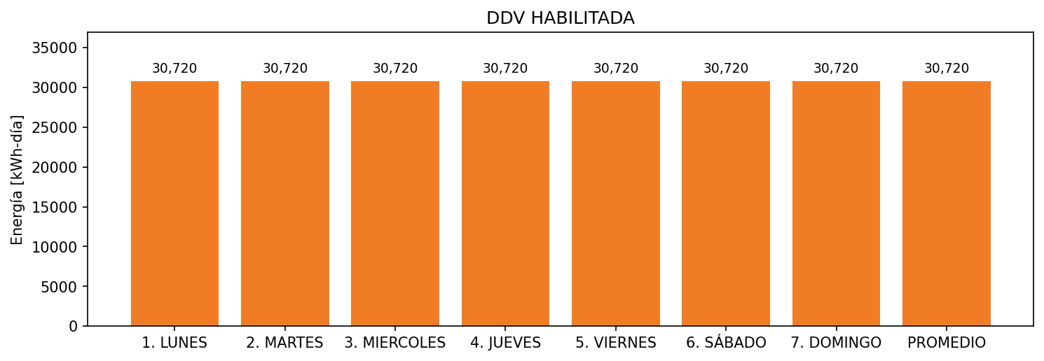

|  |  |  |  |  |  |  |  |  |  |
| --- | --- | --- | --- | --- | --- | --- | --- | --- | --- |
| **FRONTERA** | **COD SIC** | **FRT DDV** | **TIPO DDV** | **PROMEDIO** | **PRÓXIMA ACTUALIZACIÓN** | **MARGEN DE ERROR** | **ÚLTIMA PRUEBA DDV** | **DÍAS PARTICIPACIÓN** | **FECHA REFERENCIA PRÓXIMA PRUEBA DDV** |
| COLOMBINA S.A. PLANTA LA PAILA | Frt00754 | Frt35803 | GPE | 30,720 | 2026-04-15 | NO APLICA | 2021-10-17 | 4.0 | 2022-03-08 |